Tour Edge Exotics in Play for 11th Top 5 Finish of 2019 on PGA Tour Champions

Players using Tour Edge golf clubs on the PGA Tour Champions this week earned a Top 5 finish and four total Top 25 finishes at the Principal Charity Classic in Des Moines, Iowa.
- A new player to Tour Edge and a former 3–time PGA TOUR winner put a No. 3 CBX Iron-Wood into play at the Wakonda Golf Course this week. The former U.S. Senior Open champ finished tied for 5th at 11-under-par.
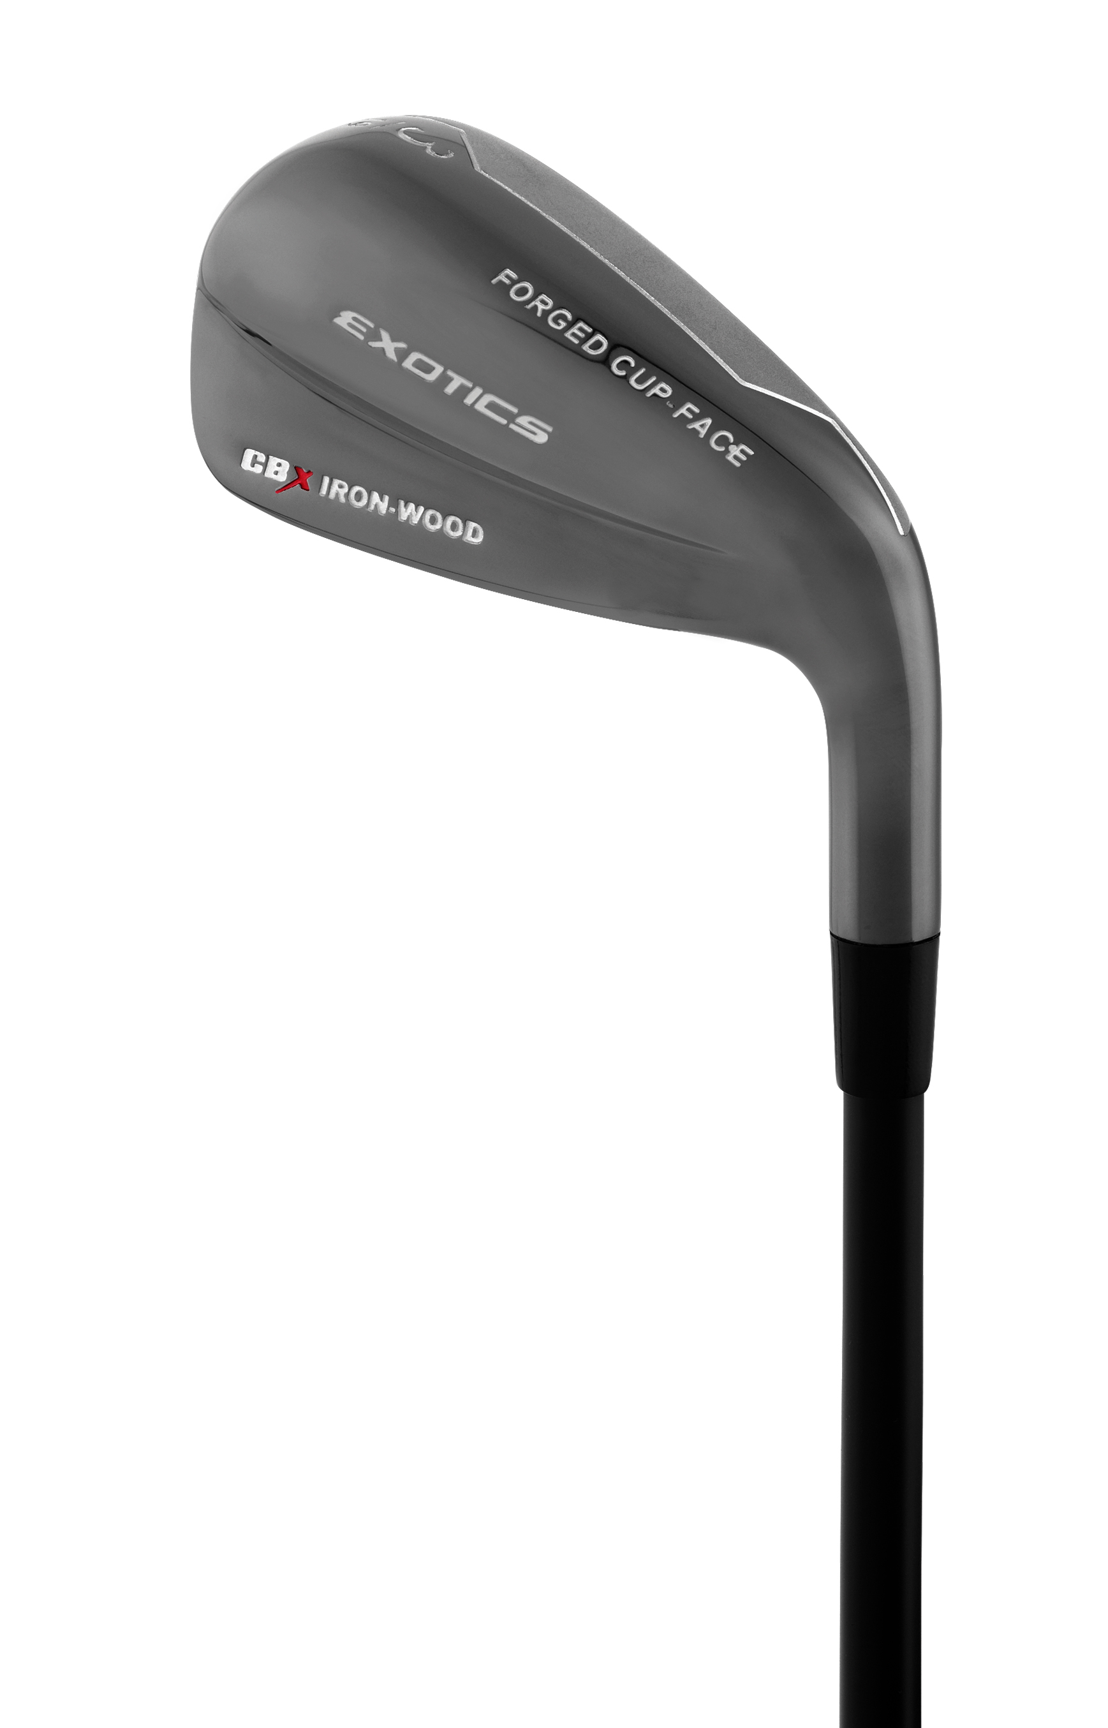
- A two-time U.S. Open champion continued playing his 19-degree Exotics CBX 119 hybrid this week en route to an 11th place finish, his 5th straight Top 25 finish since putting the Exotics club into play.
- Tour Edge staff player Duffy Waldorf also finished 11th this week for his 7th Top 25 finish this season out of his 11 events played. He now ranks 35th on the 2019 money list with $249,938 earned in prize money.
- The No. 1 ranked PGA Tour Champions player, Tour Edge staff player Scott McCarron, finished tied for 21st at the event. He now has a $76,958 lead over 2nd place.
After 12 events on the 2019 PGA Tour Champions season, Exotics have been in play for three victories, 11 Top 5 finishes, 17 Top 10 finishes and 41 Top 25 finishes.
TO SPEC EQUIPMENT NEWS: Principal Charity Classic defending Champion and Tour Edge staffer Tom Lehman was choosing three to four out of five utility clubs for his long irons at the Iowa event (#2,3,4,5 and 6 Black Pearl Exotics CBX Iron-Woods all with UST VST Silver 100 shafts.)
Lehman put in the No. 4, 5 and 6 iron-woods on Thursday, according to the Darrell Survey, and was also planning to add the No 2 or 3 iron-wood in later rounds.

